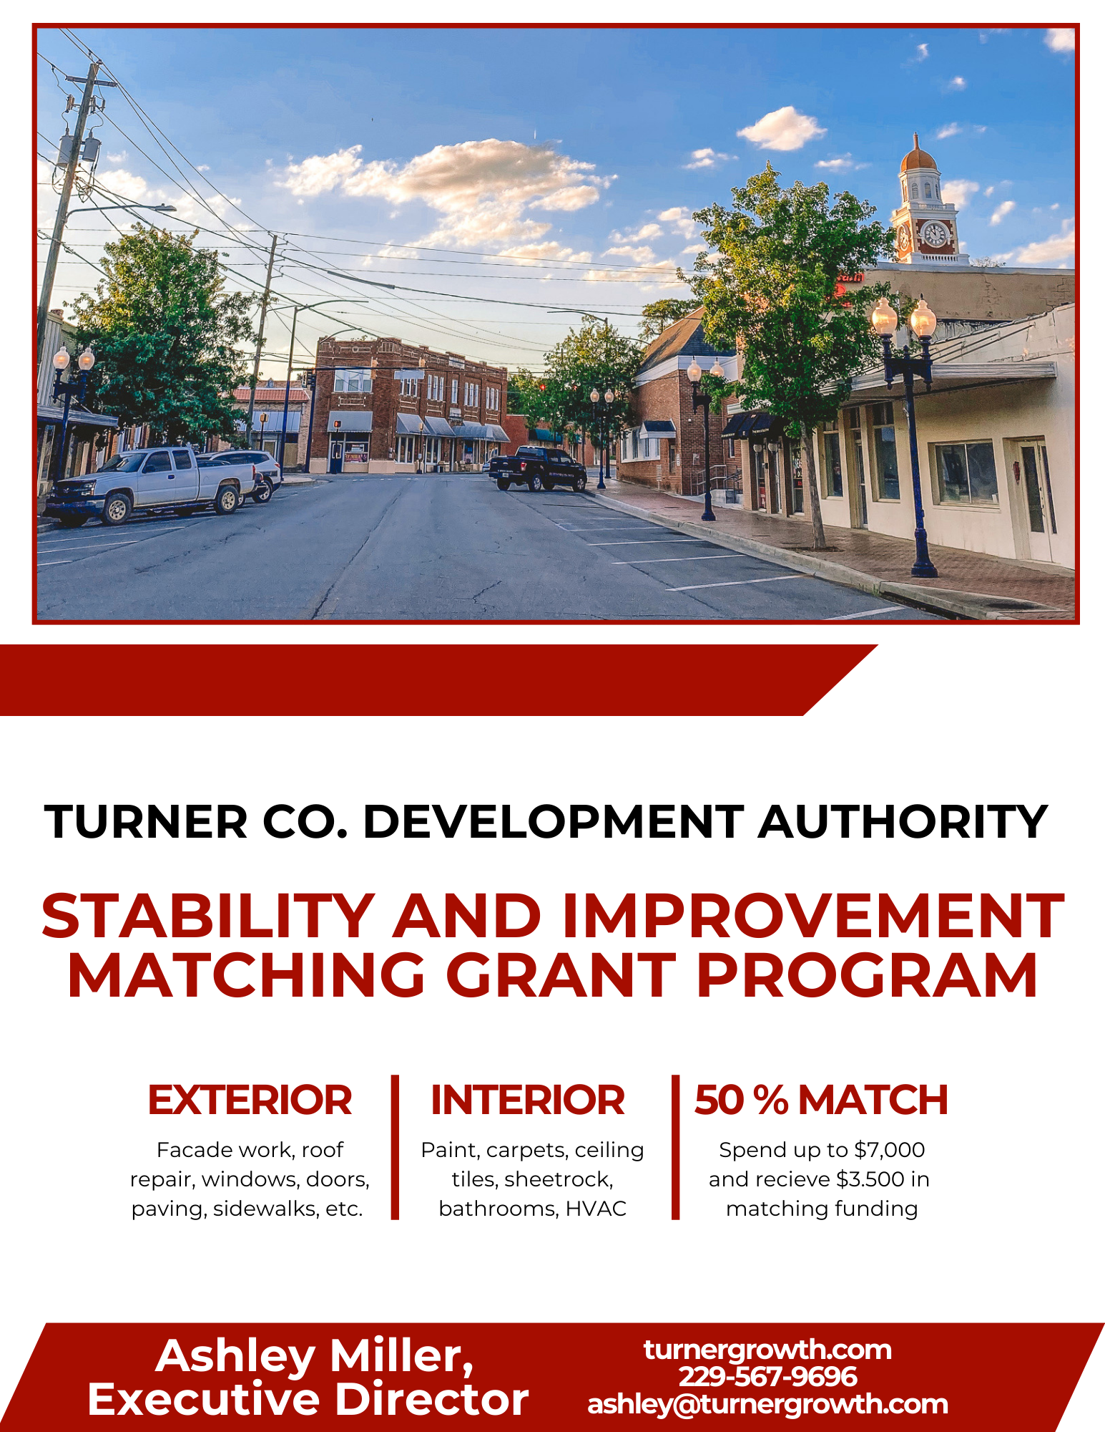

Turner County Development Authority
Stability and Improvement Matching Grant Program
Program Overview
The Turner County Development Authority (TCDA) is introducing the Stability and Improvement Matching Grant Program to encourage investment and revitalization in Ashburn, Sycamore, and Rebecca. This program provides a 50% match for project costs, up to $3,500, after project completion and approval by the TCDA.
The matching grant is designed to finance interior and exterior improvements to commercial properties in a way that is aesthetically pleasing and aligns with local design guidelines. The program aims to:
- Retain and attract businesses
- Increase utilization of commercial buildings
- Restore economic vitality
- Enhance property values
This is a reimbursement grant and is administered on a first-come, first-served basis, with an annual program cap of $70,000 (April 1st to April 1st). Applications are accepted year-round or until funds are exhausted.
For more information, contact:
Ashley Miller, Executive Director, Turner County Development Authority
📞 229-567-9696
✉️ ashley@ashburnturnerchamber.com
🌐 turnergrowth.com

Turner County Development Authority
Stability and Improvement Matching Grant
Application

Application Information For Office Use Only
Name: | App Date:
Phone: | Approval Date:
Referred By: | Tax ID:

Property Owner Information
Name: Years Owned:
Address: Phone:
City: State: Zip:
Type of Ownership: Owner’s Signature-Improvements Approved
Notes:

Business Information
Name of Business: Business Owner’s Name:
Address: Phone:
City: Zip:
Type of Business:

Proposed Improvements
Storefront Improvements:

Other Improvements:

Estimated Cost of Improvements:

Circle one: I own the property I lease/rent the property
I have read the guidelines and I understand that if the proposal is approved, I will have to make the above improvements to the property within the specified time allowed.
Applicant’s Signature ____________________________________________ Date: _____________________________

Eligible Improvements

Exterior:
Sign installation, repair, or replacement
Awning, canopy, or sunshade installation/replacement
Exterior painting or stucco, brick, or tile replacement
Window and door replacement or repair
Lighting installation or repair
Storefront redesign and historic restoration
Sidewalk, courtyard, or decorative paving
Security fencing installation or repair
Interior:
Paint, carpets, ceiling tiles, sheetrock, paneling
Office/retail space redesign
Restroom upgrades (fixtures, ADA compliance)
Roof repairs and structural stability upgrades
HVAC, electrical, and fire suppression systems
Safety and fire code compliance upgrades

Special Project Approvals:
Other improvements may be considered with special permission from the TCDA Board.

Eligibility Criteria
Applicants must:
- Be a property owner or business tenant improving an existing commercial building.
- Have property located along public streets in business districts of Ashburn, Sycamore, or Rebecca.
- Submit only one grant application per storefront at a time.
- Ensure projects have not commenced prior to grant approval.
- Match grant funds with equal or greater investment in the project.
- Maintain the property and improvements after completion.

Application Process
- Submit a completed application to TCDA (available online at turnergrowth.com or at the Chamber of Commerce office).
- Review committee evaluates applications monthly and notifies applicants of approval within 45 days.
- If approved, the applicant must provide:
  - Copy of construction contract
  - Two third-party quotes for improvements
  - Written statement selecting a contractor (e.g., lowest price, best quality, consistency)
- TCDA schedules a meeting with the building owner to finalize work details.
- Applicant obtains necessary permits and complies with all safety standards.
- Final reimbursement is issued upon:
  - Submission of invoices and proof of payment (canceled checks)
  - Photos of completed work
  - TCDA approval of final improvements
Total reimbursement shall not exceed $3,500.
For zoning and permitting questions, contact Turner County Board of Commissioners – Building and Zoning Division at 229-567-3563.

Key Program Guidelines
✔ First-come, first-served funding with priority given to projects with greater economic impact.
✔ Annual cap of $70,000 available from April 1st to April 1st.
✔ Matching grant – tenant or property owner must contribute an equal amount.
✔ Applicants are responsible for ongoing maintenance of improvements.
For additional details, contact:
📞 Ashley Miller, Executive Director, Turner County Development Authority
📍 238 E. College Ave, Ashburn GA 31714
✉️ ashley@ashburnturnerchamber.com
🌐 turnergrowth.com

